Report for assignment 4 of Yixin Yin

Button setting:  
(1)You can press ‘r’ to change shader, I have 3 shaders.

(2)You can press ‘1’ ‘2’ ‘3’ to choose the objects, ‘1’ represents the cow, ‘2’ represents the bishop and ‘3’ means the two ducks. Then you can use ‘i’, ’m’ ,’j’,’ k’

to rotate the object you choose like assignment 3.

(3)you can use wsad to move the view point around and you can use left arrow, right arrow to change the direction of the view point. I also implement the look up, and look down, since it is not the requirement, I make them annotates. If you want to check them, the codes in GLUT_KEY_UP and GLUT_KEY_DOWN is available.

(4) First, I draw the room and I use dice.png to texture the wall.

For the objects in the room, I put 4 objects in the room. I also use texture to draw one of the two ducks.

(5)I have two light sources in this project, they are at:

float position[4] = {10.0f,8.0f,6.0f,1.0f};

float position1[4] = {0.0f,0.0f,-4.0f,1.0f};

glLightfv(GL_LIGHT0, GL_POSITION, position);

glLightfv(GL_LIGHT1, GL_POSITION, position1);

I also write some code in the .vert and .frag files.

(6)I also implement the collision detect, so the view point can not go through the objects and it can not go out the walls.

Thanks

Here are some screenshot:

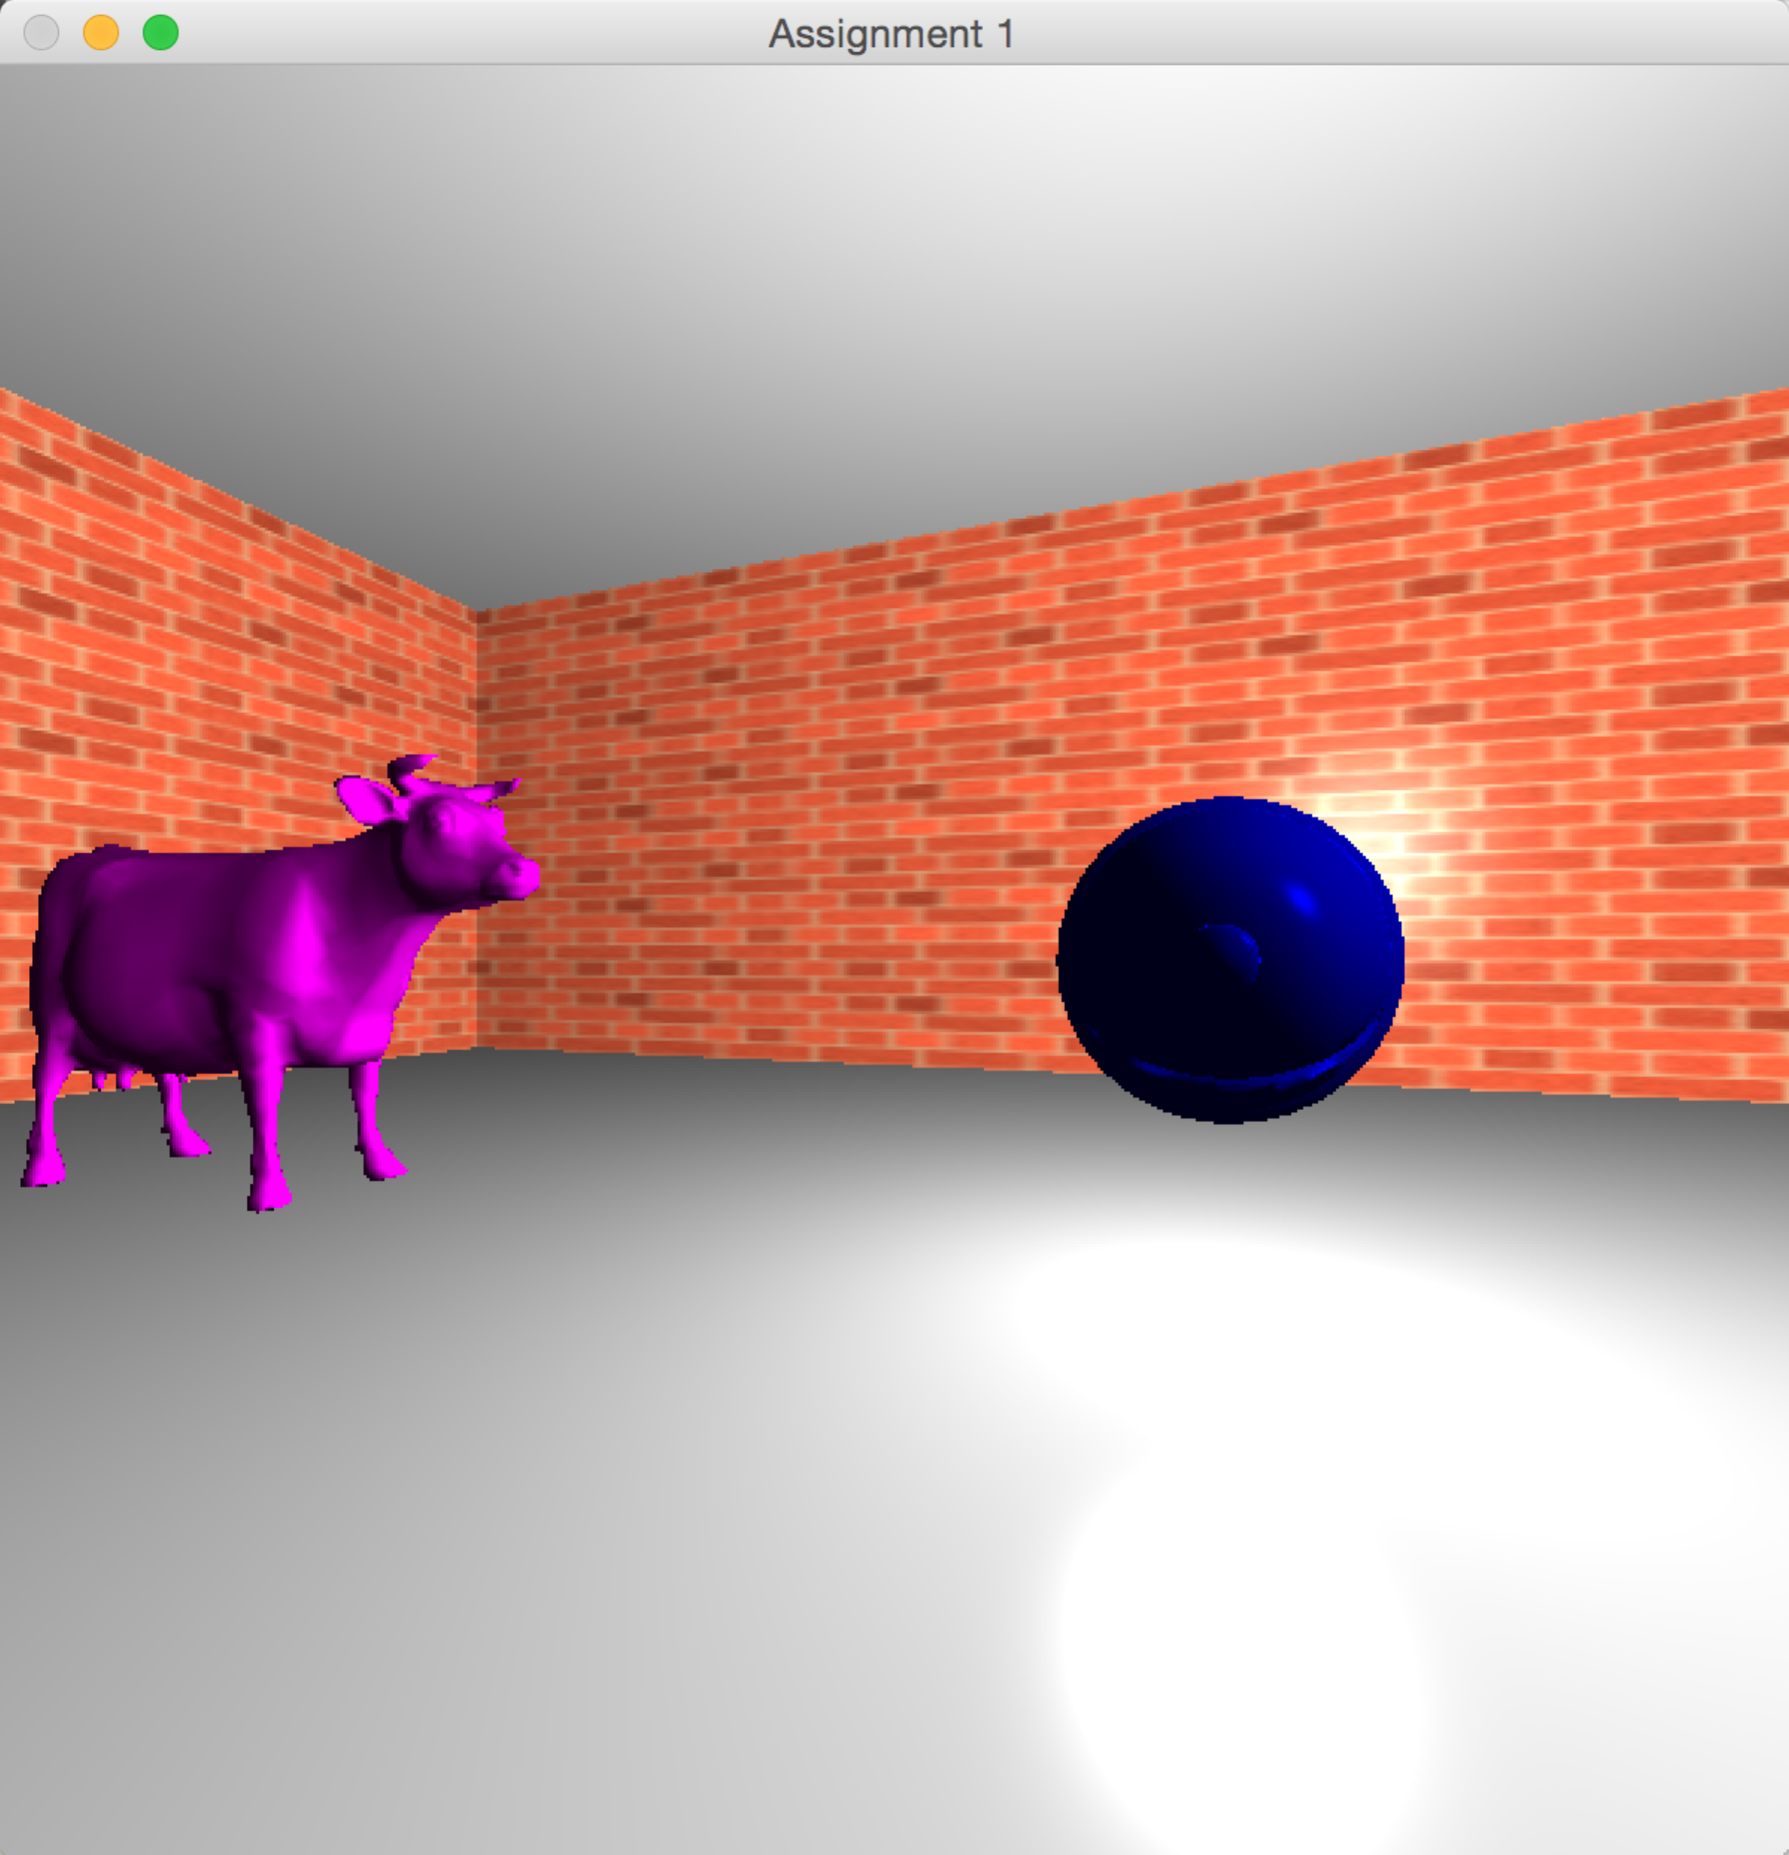

The effects are following:

(1)phong

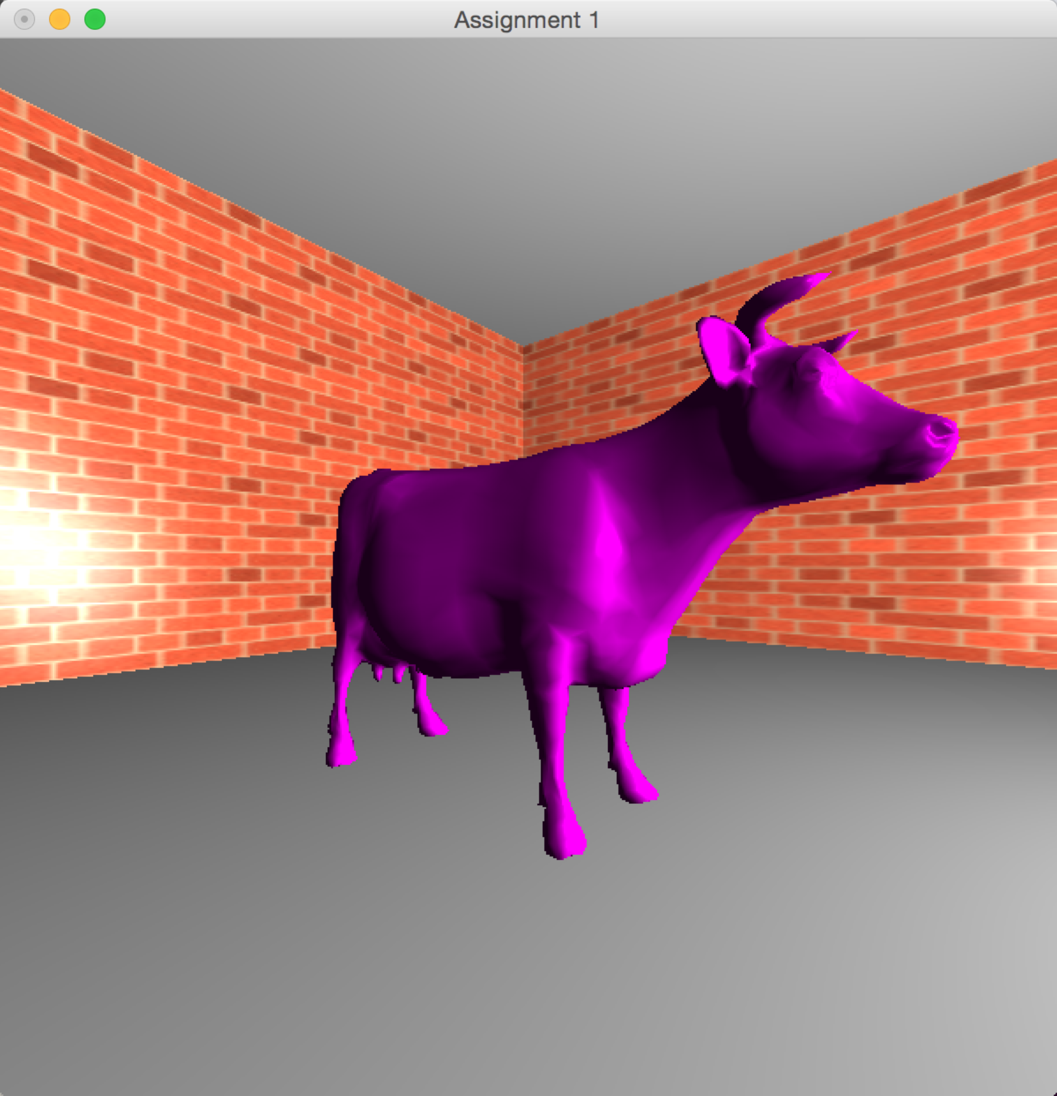

(2)gouraud

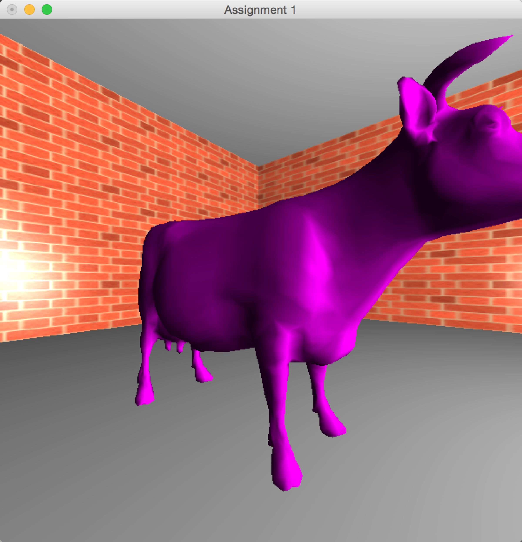

(3)toon

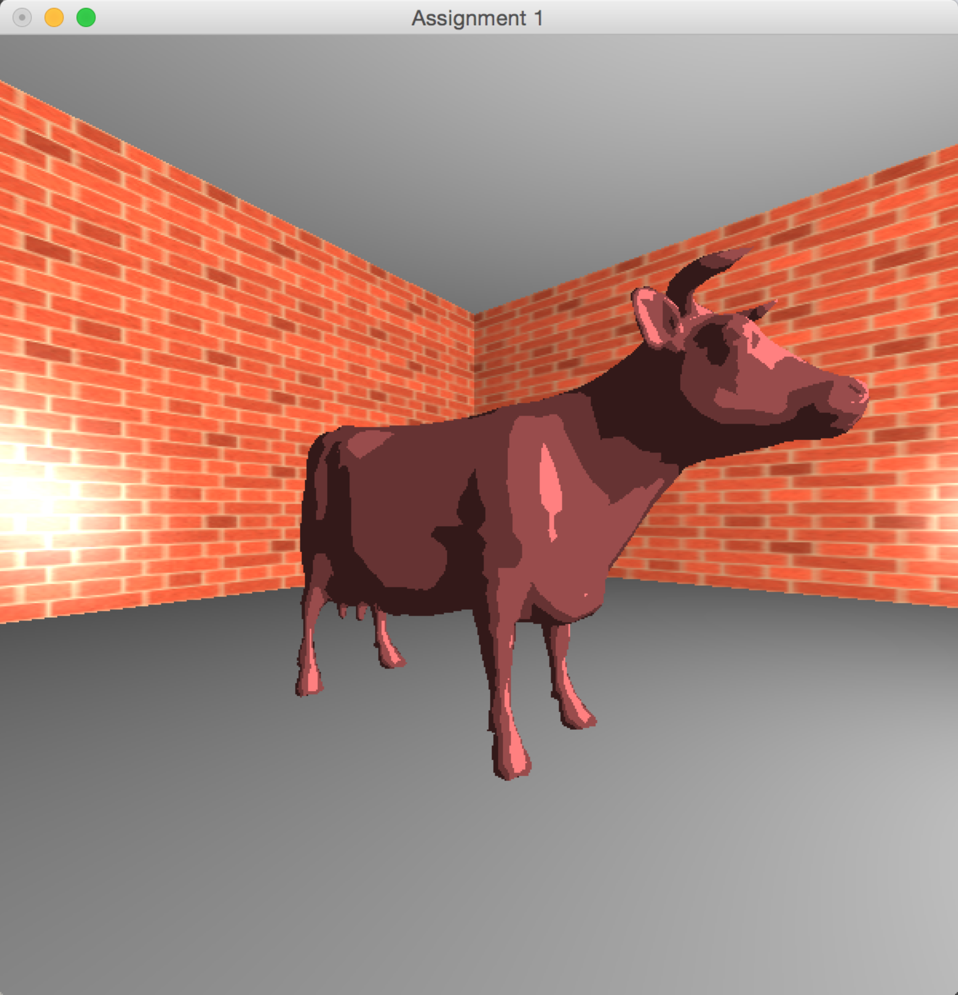

For the other duck, I use texture(duck.png) to describe it. So it looks good. I put another duck in front of it to make a comparison.

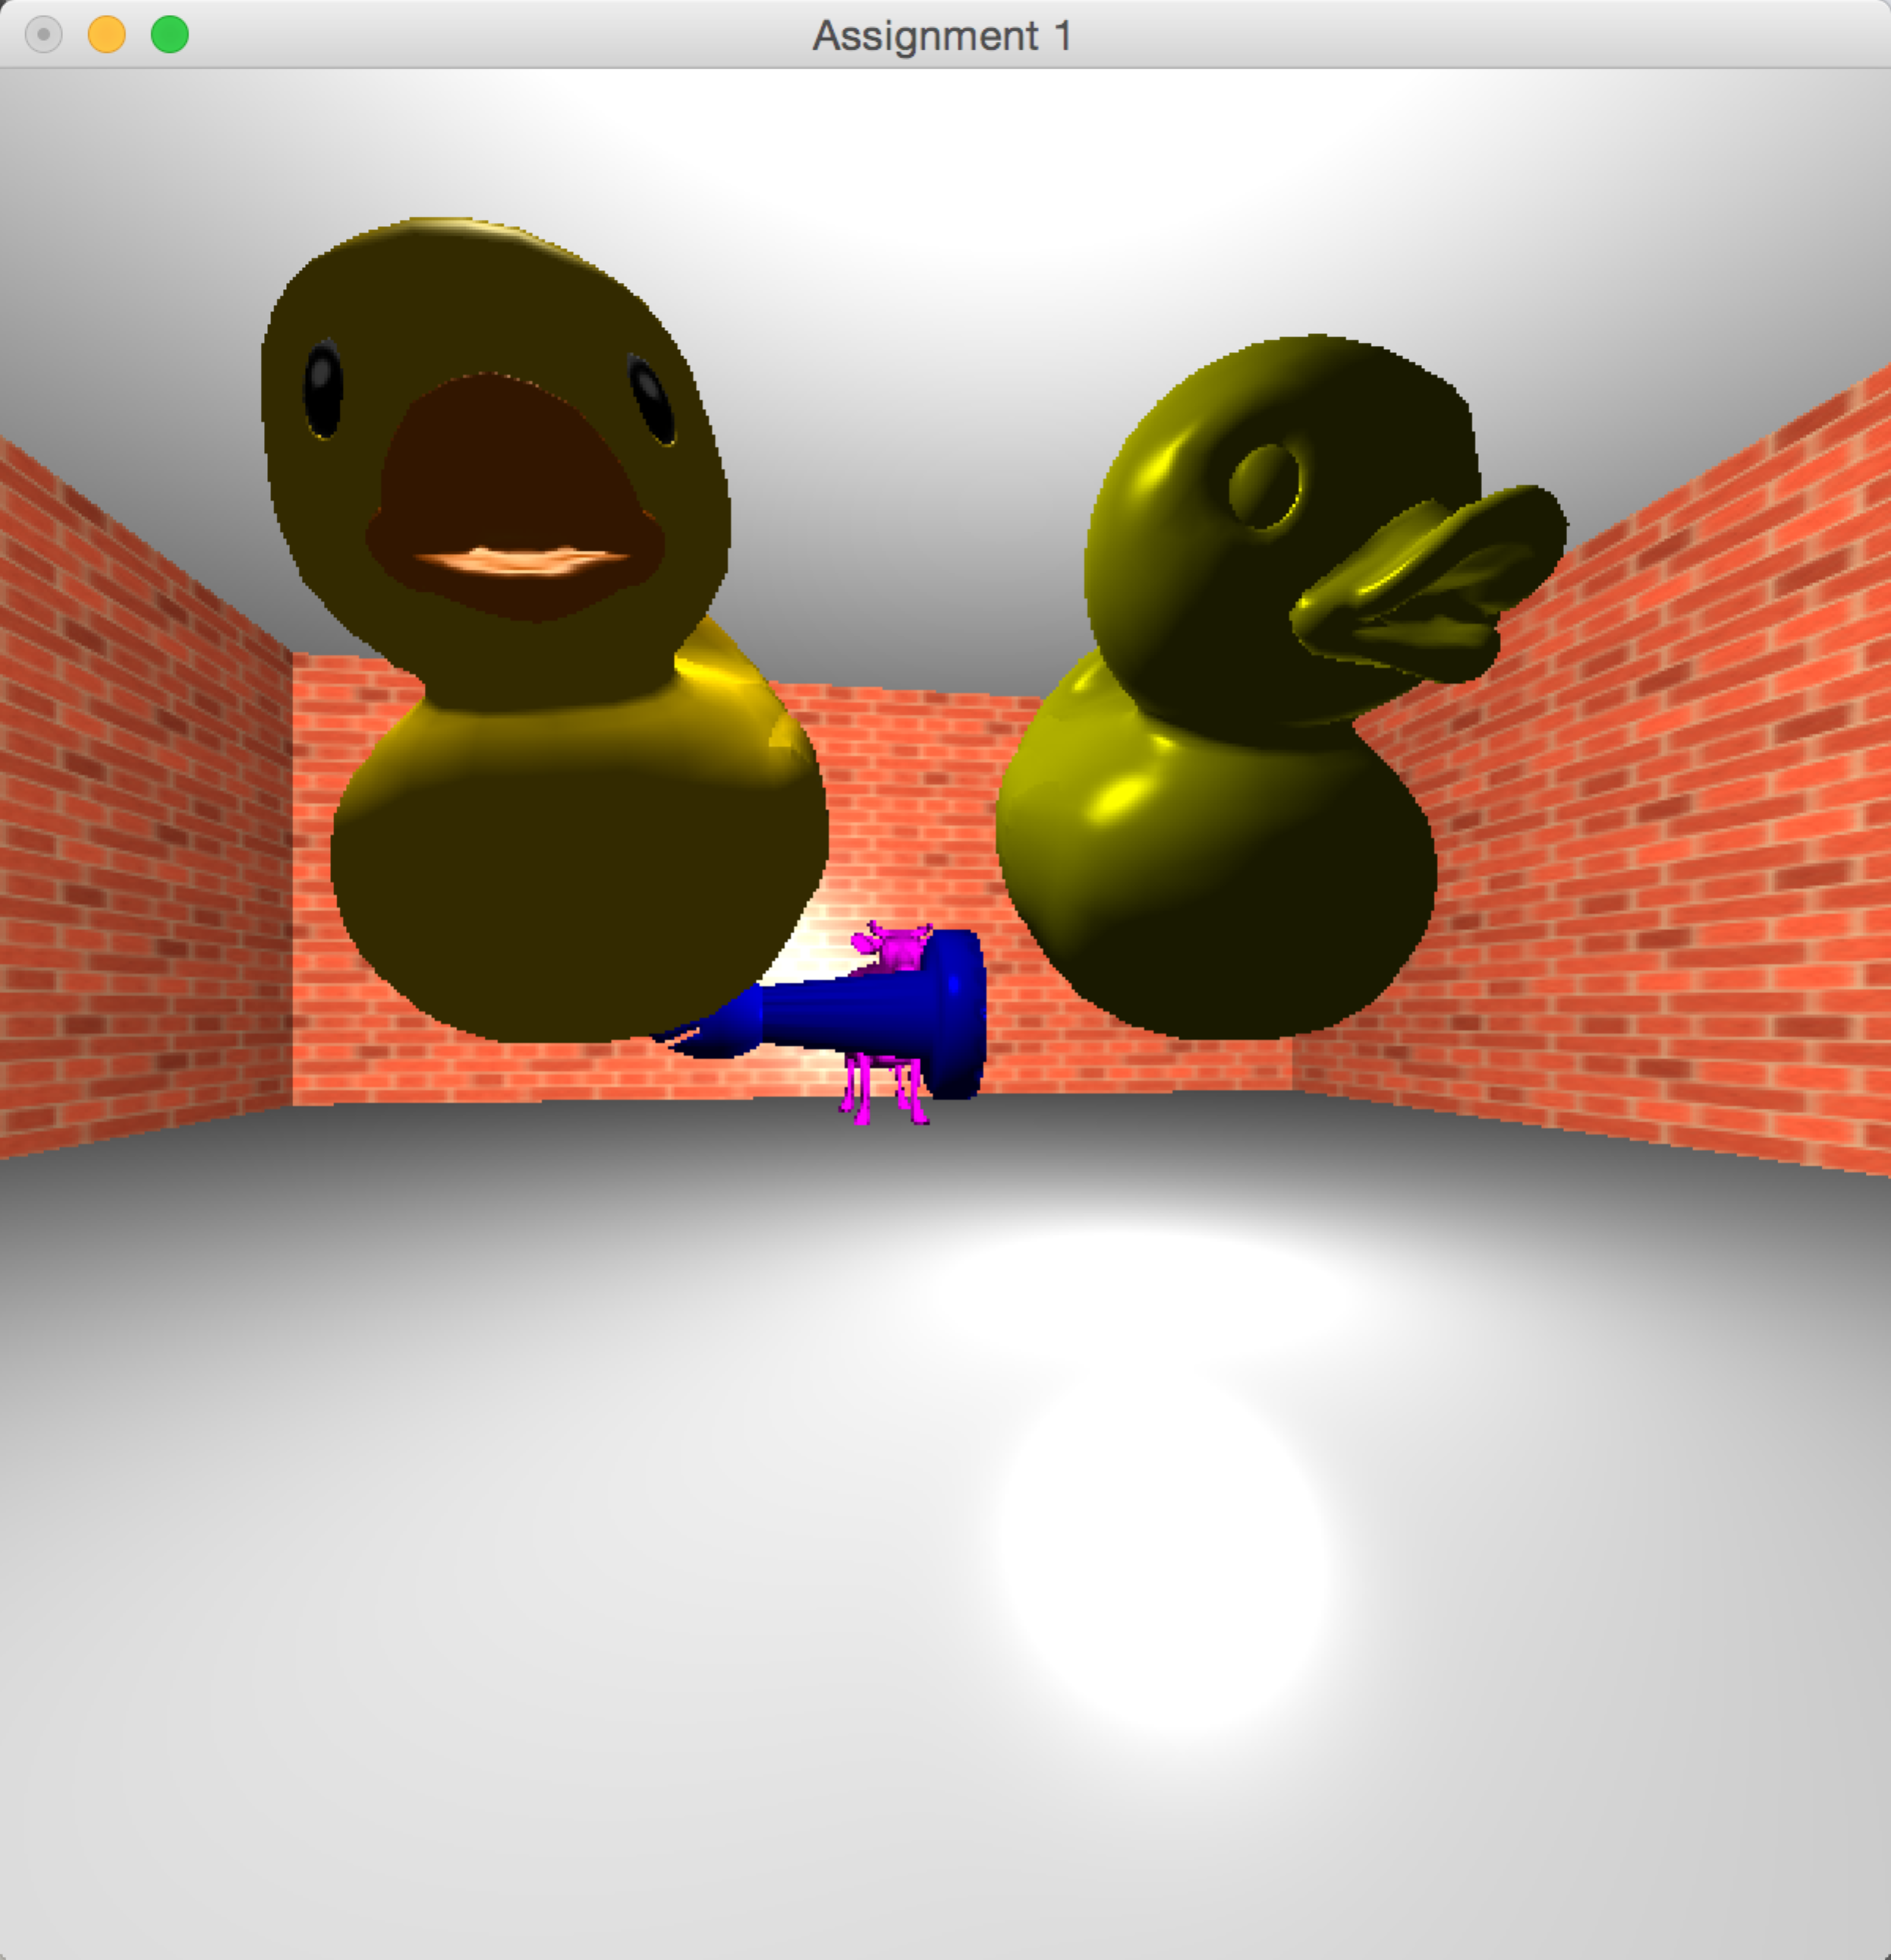

after rotation

